APPOINTMENT MANAGEMENT SYSTEM: AN APPOINTMENT MANAGEMENT SYSTEM FOR GAWARAN MATERNAL CLINIC

Submitted to the Faculty of the Department of
Computer Studies in Cavite State
University – Imus, Cavite

In partial Fulfilment of the Requirements for
the Degree Bachelor of Science
in Information Technology

PRENCIS JOY L. LIBRON
BRYAN A. LONGALONG
JASMINE A. VILLAFUERTE
May 2026

APPOINTMENT MANAGEMENT SYSTEM: AN APPOINTMENT MANAGEMENT SYSTEM FOR GAWARAN MATERNAL CLINIC

PRENCIS JOY L. LIBRON
BRYAN A. LONGALONG
JASMINE A. VILLAFUERTE

An undergraduate capstone project manuscript submitted to the faculty of the department of computer studies, Cavite State University, Imus city, Cavite in partial fulfillment of the requirements for the degree of Bachelor of Science in Information Technology with contribution no. BSIT-CAP-O1-202400-072. Prepared under the supervision of Ms. Mariella R. Leyba.

INTRODUCTION

The An Appointment Management System For Gawaran Maternal Clinic is a comprehensive full-stack application designed to digitize and streamline the daily operations of a maternity clinic. Developed using Node.js for the backend, HTML/CSS for the frontend, and Supabase as the cloud database service, the system provides a centralized platform that integrates patient management, appointment scheduling, medical records, laboratory results, delivery tracking, staff communication, and administrative functions. By consolidating these modules into a single portal, the system ensures that clinic stakeholders—administrators, doctors, nurses, staff, and patients—can access the information and tools they need in a secure and efficient manner.
The need for such a system arises from the growing demand for reliable maternal healthcare services in community-level clinics. Traditionally, these clinics rely on paper-based processes to record patient information, schedule appointments, and track medical histories. While functional, these manual methods are prone to inefficiencies and errors, particularly as patient volumes increase. The absence of automation often leads to delays in service delivery, difficulty in retrieving records, and inconsistencies in reporting. In a healthcare context where accuracy and timeliness are critical, these shortcomings can compromise the quality of care provided to mothers and their newborns.
Current problems faced by clinics include the lack of centralized dashboards that can provide real-time visibility into appointments, patient progress, and staff workload. Manual encoding not only consumes valuable time but also increases the risk of human error, such as misplaced records or incorrect entries. Furthermore, without standardized access control and audit logs, sensitive patient data is vulnerable to unauthorized access and breaches. These challenges highlight the urgent need for a secure, role-based digital platform that can automate workflows, strengthen data protection, and improve overall clinic efficiency. The Gawaran Maternal Clinic system directly addresses these issues by offering a modern, browser-accessible solution that enhances both operational management and patient care.

Project Context

Gawaran Maternal Clinic serves expectant mothers and new mothers within its community, providing essential maternal healthcare services. Prior to the implementation of the proposed system, clinic operations were managed through handwritten logbooks and manual scheduling. Appointments were recorded on paper, medical records were stored in physical folders, and staff relied on informal communication channels. Administrators depended on manual consolidation of reports, which made decision-making slow and inefficient. This workflow, while traditional, became increasingly difficult to sustain as patient numbers grew and the demand for timely care increased.
The reliance on paper-based processes introduced several operational difficulties. Appointments tracked manually often led to double-bookings and scheduling conflicts, disrupting patient care. Medical records stored in physical folders lacked backup, making them vulnerable to permanent loss due to misplacement or damage. There was no system to monitor patient status in real time, such as distinguishing between inpatient and outpatient cases or tracking trimester stages. Staff had no secure channel for internal communications, which hindered coordination, and administrators lacked consolidated reports that could provide insights into clinic performance. These issues collectively compromised efficiency, accuracy, and the overall quality of maternal healthcare delivery.
Automation is therefore essential to address these challenges. By digitizing patient records, appointments, and staff communications, the clinic can ensure secure data storage, reduce human error, and provide real-time visibility into operations. An integrated information system will automate routine transactions, safeguard sensitive patient data, and generate consolidated reports for administrators. This transformation not only improves operational efficiency but also enhances the quality of care, ensuring that mothers and newborns receive timely and accurate medical attention.

Objectives of the Study

The general objective of this study is to design, develop, and deploy a web-based management system for Gawaran Maternal Clinic that automates clinical transactions, secures patient information, and improves the overall efficiency of clinic operations. The system aims to replace outdated paper-based workflows with a centralized digital platform that enhances accuracy, accessibility, and security in maternal healthcare management.
The specific objectives of the study are as follows. First, to implement a role-based authentication system that supports five distinct user roles: Administrator, Doctor, Nurse, Staff, and Patient. This ensures that each stakeholder has access only to the modules and data relevant to their responsibilities. Second, to automate appointment scheduling with features such as real-time conflict detection, doctor availability management, and email notifications, thereby reducing scheduling errors and improving patient experience. Third, to develop a digital medical records and laboratory results module that authorized personnel can access securely, ensuring continuity of care and reducing the risk of data loss.
Fourth, the system will generate consolidated reports and statistics on patient volume, staff performance, and delivery records, providing administrators with actionable insights for decision-making. Fifth, it will enforce advanced security measures including two-factor authentication (2FA/OTP), account lockout policies, audit logging, and role-based access control (RBAC) to safeguard sensitive patient data. Finally, the system will provide a patient-facing portal where users can view appointments, access medical history, submit feedback, and engage in secure messaging with clinic staff. Collectively, these objectives ensure that the system not only modernizes clinic operations but also enhances patient care and strengthens data protection.

Purpose and Description

The Gawaran Maternal Clinic system is designed as a multi-role web portal hosted on a Node.js and Express backend, with Supabase (PostgreSQL) serving as the database. Its purpose is to provide a centralized platform that integrates all critical clinic operations into one secure and accessible system. By digitizing patient records, appointments, laboratory results, and staff communications, the system ensures that maternal healthcare services are delivered more efficiently and with greater accuracy.
The system is composed of several interconnected modules, each tailored to specific user roles and functions. The Landing Page serves as the public-facing homepage, presenting clinic services, compliance badges such as PRC, HIPAA, and RA 10173, and patient feedback to establish trust and transparency. The Authentication Module provides secure login, signup, password recovery, and two-factor authentication through email-based OTP, ensuring that only authorized users gain access. The Admin Dashboard enables administrators to manage user accounts, monitor audit logs, track staff performance, and view patient statistics through charts and reports.
For medical staff, the Doctor Dashboard offers tools for managing patient lists, appointments, medical record entries, laboratory results, delivery records, and schedules. Patients, on the other hand, benefit from the Patient Portal, which allows them to book appointments, access medical history, submit feedback, and communicate securely with clinic staff. The system also includes a Notifications Module, which delivers real-time alerts for appointments, messages, and security events, ensuring timely communication. Finally, the Reports Module generates monthly statistics on patient volume, delivery summaries, and staff performance, providing administrators and doctors with consolidated data for informed decision-making.
Together, these modules create a comprehensive management system that enhances visibility, reduces manual errors, and strengthens the overall security posture of the clinic. By integrating these features into a single platform, the Gawaran Maternal Clinic system fulfills its purpose of modernizing maternal healthcare operations and improving the quality of service for both patients and staff.

Primary users of the system include clinic administrators, doctors, nurses, administrative staff, and patients. Each role is provided with a dedicated portal that grants access only to the modules and information relevant to their responsibilities, ensuring efficiency and security in daily operations. Administrators manage accounts, audit logs, and consolidated reports; doctors oversee patient records, appointments, and laboratory results; nurses and staff assist in scheduling and patient monitoring; while patients benefit from a user-friendly portal for booking appointments, accessing medical history, and communicating securely with clinic personnel.
The system is fully compliant with the Philippine Data Privacy Act of 2012 (RA 10173) and follows HIPAA best practices for health information security. These standards ensure that sensitive patient data is protected against unauthorized access, misuse, or loss. By embedding compliance into its design, the Gawaran Maternal Clinic system not only modernizes healthcare operations but also safeguards patient trust and aligns with national and international regulations governing medical information.

Time and Place of the Study

The study was conducted at Gawaran Maternal Clinic, which served as the deployment site and primary setting for system evaluation. Development was carried out by students of the Department of Computer Studies at Cavite State University – Imus Campus, ensuring that the project combined academic rigor with practical application in a real healthcare environment.
The project timeline began in February 2026 with the planning and requirements gathering phase. This was followed by iterative cycles of design, development, and testing, allowing the team to refine features and address feedback from stakeholders. The study concluded in May 2026, marking the completion of the system’s deployment and evaluation.
Respondents for system evaluation included clinic staff, doctors, and patient representatives. Their participation was essential in validating the usability, efficiency, and security of the system. Feedback from these stakeholders provided valuable insights into real-world workflows and guided improvements, ensuring that the system effectively addressed the operational challenges of maternal healthcare management.

Scope and Limitations

The scope of the Gawaran Maternal Clinic Web-Based Management System covers a wide range of functional areas essential to maternal healthcare operations. It provides user registration and management for five distinct roles: administrator, doctor, nurse, staff, and patient. Appointment scheduling is automated with features such as availability checking, conflict prevention, and status tracking for pending, confirmed, cancelled, or completed appointments. Medical records can be created and retrieved by authorized clinical staff, including diagnosis, treatment details, and file attachments. Laboratory results are managed with status tracking to indicate whether tests are pending or completed, while delivery records are logged with details such as delivery type and date.
Additional features include patient waitlist management, secure internal messaging between system users, and a feedback and rating system for patient–doctor interactions. Administrative reporting is supported through monthly patient statistics and staff performance scores, enabling data-driven decision-making. Security is a core component of the system, with measures such as two-factor authentication (2FA/OTP), account lockout after five failed attempts with a 15-minute lockout period, role-based access control (RBAC), audit logs, Helmet.js headers, and rate limiting to protect sensitive patient information.
The limitations of the system reflect its current scope and version. Billing and payment processing are not included, as financial transactions fall outside the focus of this study. Integration with external laboratory or pharmacy systems is not supported, limiting interoperability with third-party services. A native mobile application is not provided; instead, mobile access is available through a responsive web browser interface. The system requires an active internet connection to connect to the Supabase cloud database, which may restrict usage in areas with poor connectivity. Finally, video or telemedicine consultation features are excluded from this version, as the system is designed primarily for in-clinic operations and patient management.

Conceptual Framework
INPUT
OUTPUT
PROCESS
Process Planning
• Define system architecture and role-based access requirements
• Gather functional and non-functional requirements from clinic staff
• Analyze usability and integration risks
• Design appointment scheduling and notification features
Risk Analysis
• Usability risk from multi-role portal complexity
• Data privacy risk — mitigated via RLS and audit logs
• Connectivity risk — mitigated via local JSON fallback store
• Prepare contingency plans for database/connectivity issues
Execution
• Implement modular authentication, appointment, records, and reports modules
• Integrate Supabase database, SMTP notifications, and JWT sessions
• Enforce RBAC across five user roles
• Conduct unit, integration, and user acceptance testing
• Deploy system for clinic use

APPOINTMENT MANAGEMENT SYSTEM: AN APPOINTMENT MANAGEMENT SYSTEM FOR GAWARAN MATERNAL CLINIC

Knowledge Requirements
Patient registration data and medical history
• Appointment requests and scheduling preferences
• User credentials and authentication data
• Medical records, diagnoses, and treatment notes
• Lab test requests and results
Software Requirements
• Node.js and Express.js (backend framework)
• Supabase / PostgreSQL (database)
• HTML, CSS, JavaScript (frontend)
• Nodemailer for OTP email delivery
Hardware Requirements
• Development workstation with internet access
• Network infrastructure for cloud database sync

EVALUATION
Figure 1. Conceptual framework of the study

The conceptual framework illustrates how the researchers represented the study’s paradigm, showing the relationship between input, process, and output using the Input–Process–Output (IPO) approach. This paradigm depicts the structural flow of the study and highlights the requirements, methodology, and evaluation necessary to develop the Gawaran Maternal Clinic Web-Based Management System. The framework emphasizes how patient information, appointment requests, medical data, and user credentials are transformed through authentication, scheduling, and record management into secure portals, digital records, and consolidated reports.

The knowledge requirements for the system include understanding maternal healthcare workflows, patient record management, appointment scheduling practices, and healthcare data security standards. Software requirements involve the use of Node.js and Express for backend services, Supabase (PostgreSQL) for database management, and HTML/CSS/JavaScript for frontend development. Security libraries such as Helmet.js and express-rate-limit are also required to enforce compliance with RA 10173 and HIPAA best practices. Hardware requirements include development workstations, clinic computers, and network infrastructure to support deployment and ensure reliable access to the system.

The methodology follows critical phases of planning, design, execution, and evaluation. The planning phase focused on defining system architecture, gathering functional requirements, and analyzing potential risks such as data breaches or scheduling conflicts. The design phase involved creating user interfaces, database schemas, and security protocols tailored to clinic operations. The execution phase included implementing modules such as authentication, appointment scheduling, medical records, laboratory results, and reporting, followed by iterative testing to ensure accuracy and usability. Finally, the evaluation phase assessed the system’s efficiency, security, and user satisfaction, with feedback from clinic staff and patients guiding refinements.

The output of the study is a fully functional web-based maternal clinic management system. It provides secure role-based portals, automated appointment scheduling, digital medical records, laboratory and delivery tracking, consolidated analytics reports, and audit logs. Evaluation ensures that the system meets its objectives of automating clinical transactions, securing patient information, and improving the overall efficiency of clinic operations.

Definition of Terms

Appointment Management System. A web-based application designed to automate the scheduling, tracking, and management of patient appointments, reducing conflicts and delays compared to manual paper-based methods.
Role-Based Access Control (RBAC). A security mechanism that restricts system access based on user roles (Admin, Doctor, Nurse, Staff, Patient), ensuring that each user can only access functions relevant to their responsibilities.
Two-Factor Authentication (2FA/OTP). A security feature requiring users to verify their identity through a secondary method, such as a one-time password (OTP) sent via email, in addition to their standard login credentials.
Audit Logs. System-generated records that track user activities, such as login attempts, data modifications, and administrative actions, to ensure accountability and compliance with data privacy regulations.
Supabase (PostgreSQL). A cloud-based database service used in the system to store patient records, appointments, laboratory results, and other clinical data securely.
Node.js/Express. Backend technologies used to build the server-side of the system, handling authentication, API requests, and communication between the database and frontend.
Frontend (HTML/CSS/JavaScript). The user interface components of the system, including landing pages, dashboards, and patient portals, designed for accessibility through modern web browsers.
Admin Dashboard. A system module that allows administrators to manage user accounts, monitor audit logs, track staff performance, and generate consolidated reports.
Doctor Dashboard. A system module that enables doctors to manage patient lists, appointments, medical records, laboratory results, delivery records, and schedules.
Patient Portal. A secure interface where patients can book appointments, view medical history, submit feedback, and communicate with clinic staff.
Notifications Module. A feature that provides real-time alerts for appointments, messages, and security events, ensuring timely communication between users.
Reports Module. A system component that generates monthly statistics, delivery summaries, and staff performance reports to support administrative decision-making.
Philippine Data Privacy Act (RA 10173). A national law that protects personal and sensitive information, requiring organizations to implement safeguards against unauthorized access, misuse, or loss of data.
HIPAA (Health Insurance Portability and Accountability Act). A U.S. standard for protecting health information, referenced in the system to align with international best practices for medical data security.
Helmet.js. A Node.js middleware used to secure HTTP headers, protecting the system from common web vulnerabilities.
Express-Rate-Limit. A security library that limits repeated requests to system endpoints, preventing brute-force attacks and unauthorized access attempts.

Review of Related Literature
REVIEW OF RELATED LITERATURE

This chapter discusses the review of related literature of an adhd-friendly task management system with focus tracking and productivity analytics . This literature and study review aided the researches in gaining familiarity with and understanding the topic.

Related Literature

I. Appointment Management Systems

According to Alhassan (2025), appointment management systems were designed to address inefficiencies in manual scheduling methods that often resulted in double bookings, misplaced records, and delays in service delivery. The study aimed to develop a centralized digital platform that integrated appointment scheduling, patient records, and staff communication to improve healthcare efficiency. The scope of the system included modules for authentication, scheduling, reporting, and secure data handling. Using the System Development Life Cycle (SDLC) approach, the researchers gathered requirements through surveys and interviews, designed the system architecture, and implemented the modules with web-based technologies. Testing was conducted through iterative unit and integration methods, followed by user acceptance evaluation with clinic staff and patients. Results demonstrated that the system significantly reduced scheduling conflicts, improved accessibility of medical records, and enhanced administrative decision-making, thereby validating the effectiveness of automation in healthcare operations.

In comparison, the Gawaran Maternal Clinic Web-Based Management System adapts these principles of automation and integration to maternal healthcare. While Alhassan’s study focused broadly on appointment scheduling and patient records, the Gawaran system expands the scope by incorporating laboratory results, delivery tracking, patient feedback, and secure communication channels. Both systems share the objective of reducing inefficiencies and improving service delivery, but the Gawaran system emphasizes maternal care workflows, ensuring that appointments, medical records, and patient monitoring are seamlessly integrated. This adaptation demonstrates how appointment management concepts can be tailored to specialized healthcare contexts, enhancing operational efficiency and patient satisfaction.

II. Electronic Medical Records (EMR) Systems

According to Menachemi (2025), electronic medical records (EMR) systems were introduced to digitize patient information and improve continuity of care. The study highlighted that paper-based medical records were prone to loss, misplacement, and inconsistencies, which compromised patient safety. The proposed EMR system aimed to provide secure, accessible, and centralized patient data management. The methodology involved designing a database-driven application, collecting requirements from healthcare professionals, and conducting iterative testing to ensure accuracy and usability. Results showed that EMR adoption improved clinical decision-making, reduced medical errors, and enhanced patient outcomes, validating the importance of digital record systems in healthcare.

The Gawaran Maternal Clinic system builds upon these EMR concepts by integrating medical records directly into its maternal care workflows. Unlike general EMR systems, which focus on broad patient populations, the Gawaran system emphasizes maternal-specific records such as trimester tracking, delivery history, and laboratory results. Both systems highlight the importance of digitization for accuracy and accessibility, but the Gawaran system adapts EMR principles to ensure that maternal healthcare providers can access critical patient information in real time. This adaptation strengthens continuity of care for expectant mothers and enhances the clinic’s ability to deliver timely interventions.

III. Laboratory Information Systems (LIS)

According to McGowan (2025), laboratory information systems were designed to streamline laboratory workflows, including test requests, results tracking, and reporting. The study addressed the problem of delays and inaccuracies in manual laboratory processes, proposing a digital solution that integrates laboratory data with clinical records. The methodology included system design, database integration, and pilot testing in small clinics. Evaluation demonstrated that LIS improved diagnostic reliability, reduced turnaround times, and enhanced communication between laboratory staff and physicians. The findings underscored the role of LIS in ensuring timely and accurate diagnostic support for patient care.
The Gawaran Maternal Clinic system adapts LIS principles by embedding laboratory results management within its broader maternal care platform. While McGowan’s LIS focused on general diagnostic workflows, the Gawaran system tailors laboratory tracking to maternal health needs, ensuring that test results are linked to patient records and pregnancy monitoring. Both systems emphasize accuracy and timeliness, but the Gawaran system integrates laboratory data with appointment scheduling and medical records, creating a unified workflow for maternal care. This adaptation ensures that diagnostic information is not siloed but directly supports patient monitoring and clinical decision-making.

IV. Healthcare Communication Systems

According to Ventola (2025), healthcare communication systems were developed to provide secure messaging and coordination among clinic staff, doctors, and patients. The study identified that informal communication channels such as handwritten notes or verbal instructions often led to miscommunication and inefficiencies. The proposed system introduced secure, role-based communication features integrated into clinical workflows. The methodology involved designing a web-based messaging platform, collecting feedback from healthcare staff, and conducting usability testing. Results showed that secure communication systems reduced errors, improved patient engagement, and enhanced workflow efficiency, highlighting their importance in modern healthcare environments.

The Gawaran Maternal Clinic system incorporates these communication principles by embedding secure internal messaging and patient feedback modules. While Ventola’s study emphasized general healthcare communication, the Gawaran system adapts these features to maternal care, ensuring that doctors, nurses, and patients can coordinate effectively regarding appointments, medical records, and delivery schedules. Both systems reduce miscommunication by replacing informal channels with structured digital communication, but the Gawaran system enhances this by integrating communication directly into maternal workflows. This adaptation ensures that patient engagement and staff coordination are strengthened, improving the overall quality of maternal healthcare delivery.

V. Healthcare Data Security and Privacy Systems

According to Rindfleisch (2025), healthcare data security systems were created to protect sensitive patient information from unauthorized access, breaches, and misuse. The study addressed the growing concern of data privacy violations in healthcare institutions, proposing advanced security measures such as two-factor authentication, audit logs, and role-based access control. The methodology included system design with embedded security protocols, simulation of potential breaches, and evaluation through penetration testing. Results confirmed that implementing robust security features safeguarded patient trust, ensured compliance with data privacy laws such as RA 10173 and HIPAA, and strengthened the overall integrity of healthcare systems.

The Gawaran Maternal Clinic system adapts these security principles by embedding advanced measures such as OTP-based authentication, account lockout policies, audit logging, and role-based access control. While Rindfleisch’s study emphasized compliance with privacy regulations in general healthcare, the Gawaran system applies these safeguards specifically to maternal healthcare data, ensuring that sensitive patient records are protected. Both systems highlight the importance of security in maintaining trust and compliance, but the Gawaran system integrates these measures into a maternal care platform, balancing accessibility with protection. This adaptation ensures that patient data remains secure while supporting efficient clinic operations.

Review of related Studies
REVIEW OF RELATED STUDIES

I. Online Appointment Scheduling Systems

According to Puri and Upadhyay (2021), online appointment scheduling systems were designed to reduce waiting times, minimize scheduling conflicts, and improve patient satisfaction by allowing patients to book, reschedule, and cancel appointments digitally. Their findings revealed that such systems optimize healthcare resources and reduce administrative burden, particularly when integrated with electronic health records and real-time availability features. In relation to the Gawaran Maternal Clinic Web-Based Management System, these concepts are directly applied to automate appointment scheduling, ensuring that expectant mothers can access timely care while administrators minimize errors and improve efficiency.

II. Web Ecosystem for Healthcare Appointment Management

Maluyo, Osorio, Caballero, and Albina (2022) developed a web ecosystem for healthcare appointment management that included account registration, doctor availability listings, specialty-based search, and a chat tool for health inquiries. Their study found that the system improved inclusivity and reduced appointment wait times, with usability testing among 60 users earning a “Very Good” rating overall. In relation to the Gawaran Maternal Clinic system, this study supports the integration of patient-facing portals and secure communication features, ensuring that patients can book appointments, access medical records, and interact with clinic staff in a streamlined and user-friendly manner.

III. Assimilation of Medical Appointment Scheduling Systems

The study on the assimilation of medical appointment scheduling systems (2023) examined both user-oriented outcomes, such as patient satisfaction, and technical perspectives, such as algorithm optimization. Findings showed that these systems improved efficiency by reducing patient waiting times and enhancing clinic workflow, while predictive algorithms balanced patient demand with physician availability. In relation to the Gawaran Maternal Clinic system, this research validates the importance of conflict detection and doctor availability management, which are embedded in the clinic’s scheduling module to ensure smooth maternal healthcare operations.

IV. Integration of Appointment Systems with Electronic Health Records

Puri and Upadhyay (2021) also highlighted the benefits of integrating appointment scheduling systems with electronic health records, noting that such integration enhances continuity of care and reduces duplication of records. Their findings demonstrated that physicians could align appointments with medical needs more effectively, improving clinical decision-making and patient trust. In relation to the Gawaran Maternal Clinic system, this principle is applied through the integration of appointment scheduling with digital medical records and laboratory results, ensuring that maternal care providers have comprehensive access to patient information during consultations.

V. Patient-Centered Digital Appointment Systems

Maluyo, Osorio, Caballero, and Albina (2022) emphasized the importance of patient-centered digital appointment systems, which incorporate features such as self-service scheduling, reminders, and secure communication channels. Their findings revealed that patient-centered design reduces missed appointments and improves satisfaction by empowering patients to manage their own schedules. In relation to the Gawaran Maternal Clinic system, these concepts are adapted through the patient portal, which allows mothers to book appointments, view medical history, and communicate securely with clinic staff, thereby enhancing engagement and trust in maternal healthcare services.

Synthesis

The reviewed studies collectively emphasize the importance of digitizing healthcare operations to address inefficiencies in manual systems. Alhassan (2025) and Puri & Upadhyay (2021) both highlighted that appointment management systems reduce scheduling conflicts, improve patient satisfaction, and optimize resource allocation. Similarly, Menachemi (2025) and McGowan (2025) demonstrated that electronic medical records and laboratory information systems enhance accuracy, accessibility, and timeliness in clinical workflows. Ventola (2025) and Maluyo et al. (2022) further underscored the role of secure communication platforms and patient-centered portals in improving engagement and reducing errors. A common trend across these studies is the reliance on centralized, web-based platforms that integrate multiple modules—appointments, records, communication, and reporting—to streamline healthcare delivery.

Despite these advancements, most systems reviewed were designed for general healthcare contexts and did not specifically address the unique needs of maternal clinics. For instance, while EMR systems improve continuity of care, they rarely include maternal-specific features such as trimester tracking or delivery records. Similarly, appointment scheduling systems often lack integration with laboratory results and patient feedback mechanisms. These gaps highlight the need for specialized solutions tailored to maternal healthcare. The Gawaran Maternal Clinic Web-Based Management System builds upon the strengths of existing studies by incorporating appointment scheduling, medical records, laboratory tracking, delivery monitoring, secure communication, and advanced security measures into one unified platform. By addressing the limitations of prior systems, this study contributes a specialized solution that enhances operational efficiency, strengthens data protection, and improves the overall quality of maternal healthcare services.

Methodology

The study used a quantitative descriptive research design to evaluate the effectiveness of the Gawaran Maternal Clinic Web-Based Management System. This design was chosen because it allowed the researchers to describe existing conditions, gather measurable data, and analyze the impact of the system on clinic operations and patient satisfaction. The research was conducted at Gawaran Maternal Clinic in Zapote I Bacoor, Cavite, City serving as the primary location for both system deployment and evaluation. The timeline of the study spanned from February 2026, when planning and requirements gathering began, until May 2026, when the system was fully implemented and tested.

The respondents of the study were clinic staff, doctors, and patient representatives from Gawaran Maternal Clinic. A total of fifty participants were included, and their names were drawn from clinic records such as Tuando Eleonor Pedotera, Dizon Faustina Ozon, Rempojo Gerardo Baquerro, Samson Haydee Mercader, Zamora Shaun Michael Dumdum, Albino Christy Balibado, Barron Chuckie Norman Bejerano, Fernando Rosanna Diaz, Francisco Mary Joy Gonzales, and Legaspi Rolando Nigos. Participants were selected using purposive sampling to ensure that both healthcare providers and patients were represented, thereby providing diverse perspectives on the system’s usability and effectiveness.

The primary research instrument used was a researcher-made questionnaire consisting of twenty items. The questionnaire was divided into sections covering appointment scheduling, medical record accessibility, laboratory results management, communication features, and data security. Each item was structured using a Likert scale format ranging from one to five to measure agreement and satisfaction.

The researchers first sought permission from the clinic administrator to conduct the study. After approval was granted, questionnaires were distributed to the selected respondents during clinic hours. Respondents were given sufficient time to answer, and completed forms were collected immediately to ensure accuracy. In addition to the questionnaires, informal interviews were conducted with doctors and staff to validate responses and gather qualitative insights.

The gathered data were analyzed using frequency, percentage, and mean to interpret the responses. Weighted mean scores were computed to determine the overall level of satisfaction with each system feature. Qualitative feedback from interviews was subjected to thematic analysis, highlighting recurring issues and suggestions. The combination of quantitative and qualitative analysis provided a comprehensive evaluation of the system’s effectiveness.
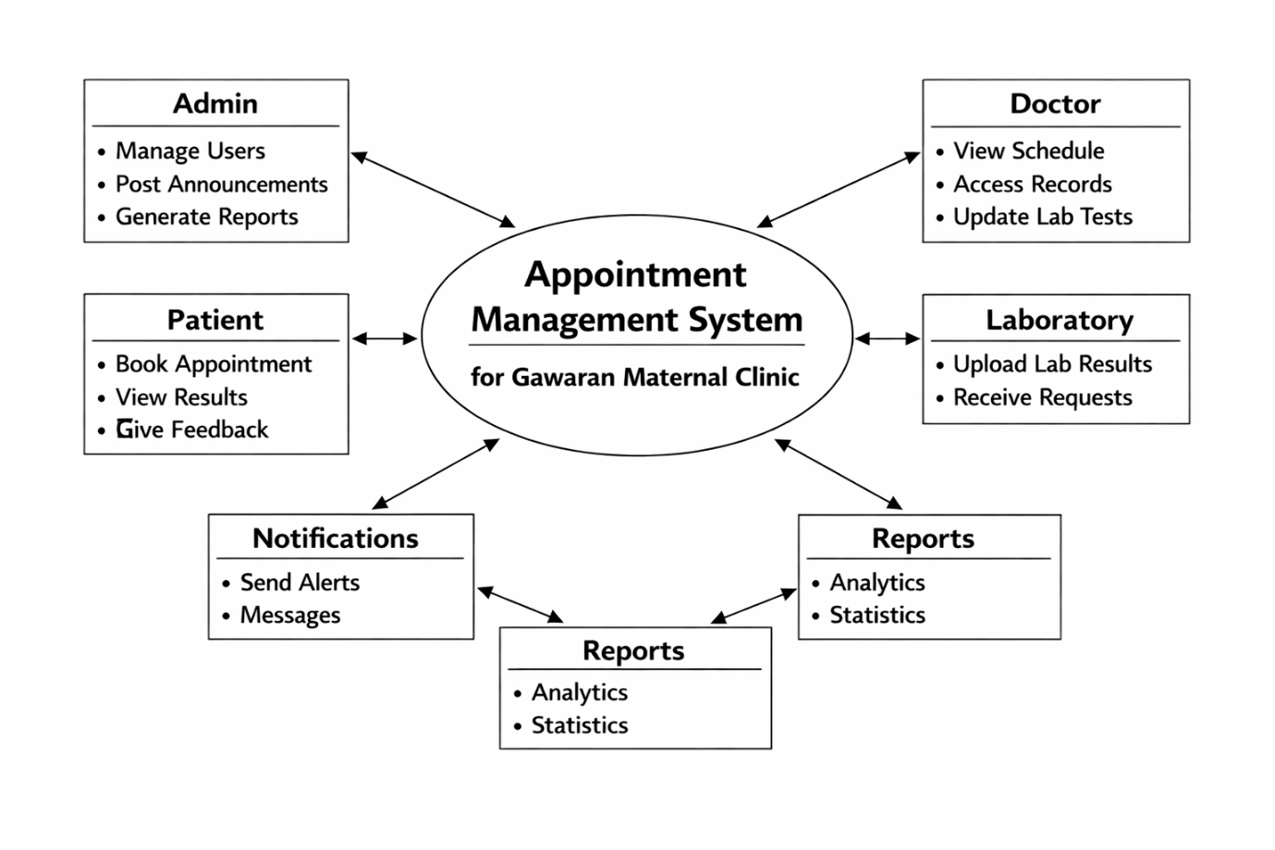

Figure 2: Context Diagram

Figure 3: Entity Relationship Diagram

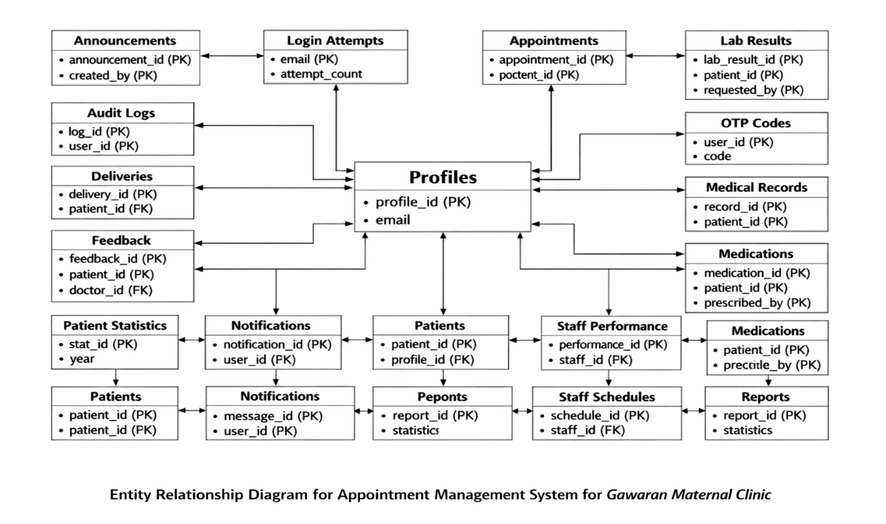

Figure 3: Entity Relationship Diagram


DOCTOR
Manage Users

Manage Appoinments

View Schedule
Upload Results


Book Appointment

View Results

PATIENT
ADMIN
Provide Feedback

Access Records

Manage Scurity

Figure 4: Use Case Diagram
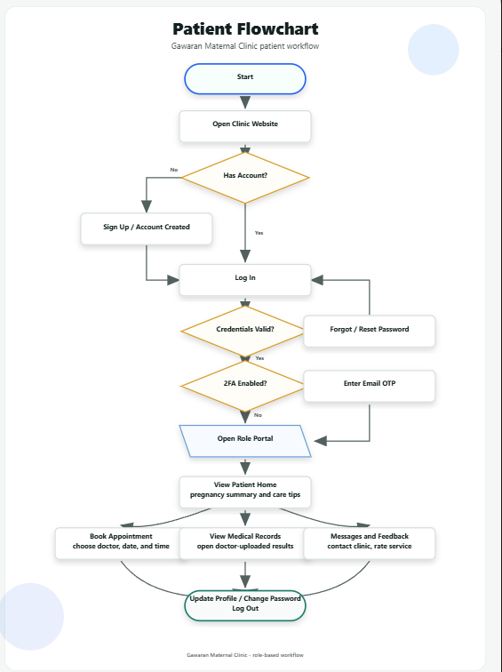

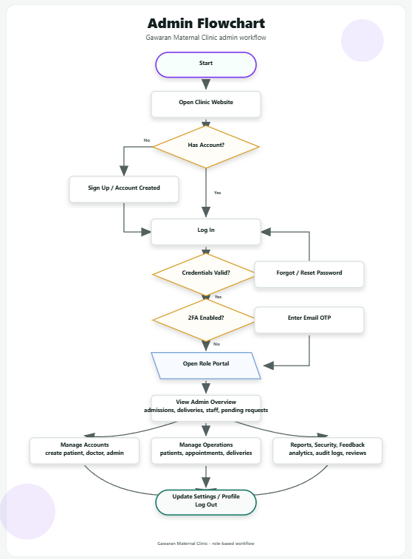

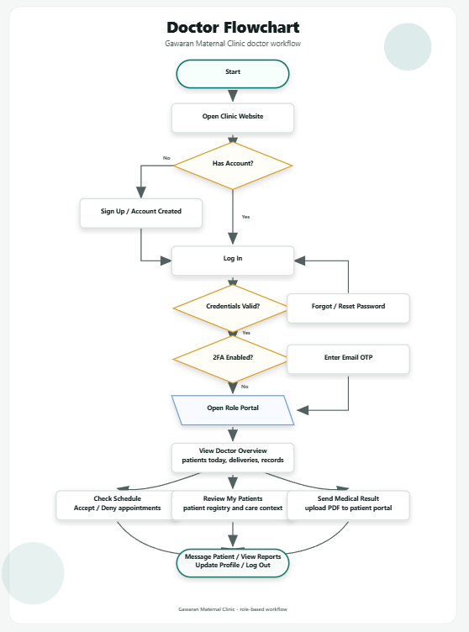

SYSTEM DESIGN & IMPLEMENTATION

System Architecture
The Gawaran Maternal Clinic system is designed as a web-based clinic management application with three main user roles: Admin, Doctor, and Patient. The system follows a client-server architecture where users interact with the system through a web browser, while the server handles authentication, data processing, access control, and communication with the database.

The frontend is composed of HTML, CSS, and JavaScript pages. It provides the user interface for login, signup, dashboards, appointments, medical records, messaging, reports, feedback, and profile management. The interface changes depending on the logged-in user’s role, ensuring that each user only sees the features allowed for them.

The backend is built using Node.js with Express.js. It manages all API requests from the frontend, including user authentication, dashboard statistics, appointment booking, medical record submission, messaging, feedback, staff management, and reports. The backend also applies security rules such as role-based access control, login validation, two-factor authentication, and protected API routes.

The database layer uses Supabase, which provides authentication services and a PostgreSQL database. The database stores user profiles, patient records, appointments, medical records, lab results, messages, feedback, notifications, staff data, deliveries, and audit logs. Supabase also supports secure user sessions and password recovery.

The system uses REST APIs to connect the frontend and backend. When a user performs an action, such as booking an appointment or uploading a medical record, the frontend sends a request to the backend API. The backend validates the request, checks the user’s role, processes the data, and returns the appropriate response to the frontend.

Overall, the system architecture allows the clinic to manage patient care, doctor schedules, administrative tasks, and communication in one centralized platform.

Features of the System

The system includes different modules based on the role of the user.
Admin Features

The Admin has the highest level of access in the system. The Admin dashboard provides an overview of clinic operations, including admitted patients, deliveries, active staff, and pending appointments.

The Admin can manage patient accounts by creating new patient profiles and viewing the patient registry. The Admin can also manage doctor and staff accounts by creating user accounts and assigning proper roles. Appointment records can be viewed and managed, allowing the Admin to monitor clinic scheduling.

The Admin also has access to deliveries, medical records, reports, security, feedback, and profile settings. The reports module provides clinic analytics such as patient satisfaction, ward occupancy, monthly visits, and delivery types. The security module includes role-based access information, two-factor authentication status, appointment conflict control, and audit logs. The feedback module allows the Admin to review patient feedback and service ratings.

Doctor Features

The Doctor dashboard provides an overview of daily clinical tasks such as patients scheduled for the day, scheduled deliveries, medical records, and notifications.

Doctors can view assigned patients and access patient-related information needed for care. They can also manage their appointment schedule by accepting or denying appointment requests. The system includes schedule availability checking to prevent conflicts and overlapping approved appointments.

Doctors can create and send medical records or results to patients. This includes uploading PDF medical results and adding summaries, diagnosis, and treatment notes. Doctors can also access delivery records, communicate with patients through the messaging module, view reports, and update their profile settings.

Patient Features

Patients can create an account through the signup page and log in to their patient portal. The Patient dashboard shows personal health-related information such as pregnancy summaries, doctor-approved care tips, upcoming appointments, medical records, lab results, medications, and notifications.
Patients can book appointments by selecting the appointment type, preferred doctor, date, and available schedule. They can view the status of their appointment requests, whether pending, confirmed, or denied.

Patients can also view medical records uploaded by doctors, open medical result files, send messages to clinic staff or doctors, and submit feedback about clinic services. The feedback module allows patients to rate the service, add comments, and choose whether the review may be displayed publicly. Patients can also update their profile, change their password, and review login history.

Security Features

The system includes authentication, password recovery, account validation, two-factor authentication through email OTP, role-based access control, and audit logging. These features help protect patient data and ensure that only authorized users can access sensitive clinic information.

APPENDICES

Figure 4.1: Log in and Sign Up
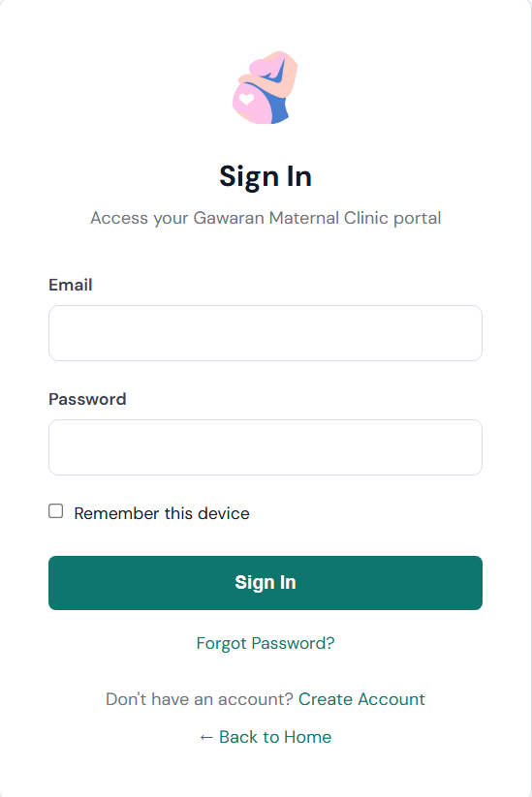
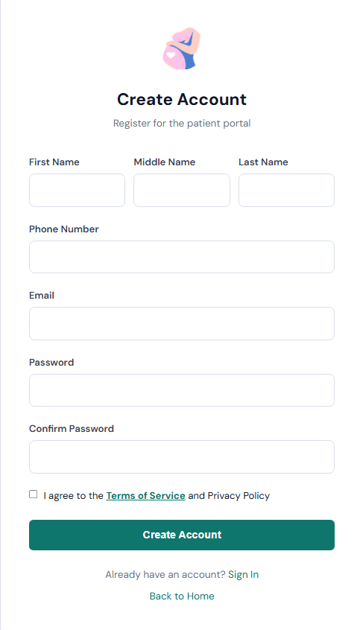

The login page allows registered users to access the Gawaran Maternal Clinic portal by entering their email address and password. It also includes a “Remember this device” option, a forgot password link, a create account link, and a back-to-home option for easier navigation.

The Sign up page is used for patient registration. It collects the user’s first name, middle name, last name, phone number, email, password, and password confirmation. Before creating an account, the user must agree to the Terms of Service and Privacy Policy.

Figure 4.2: Patient Dashboard
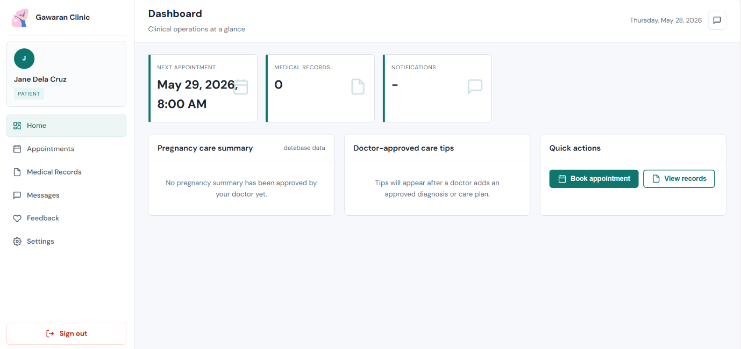

The patient dashboard displays the main overview of the patient portal. It shows the patient’s next appointment, number of medical records, notifications, pregnancy care summary, doctor-approved care tips, and quick action buttons for booking appointments or viewing records.

Figure 4.3: Appointment Booking / Queue Processing
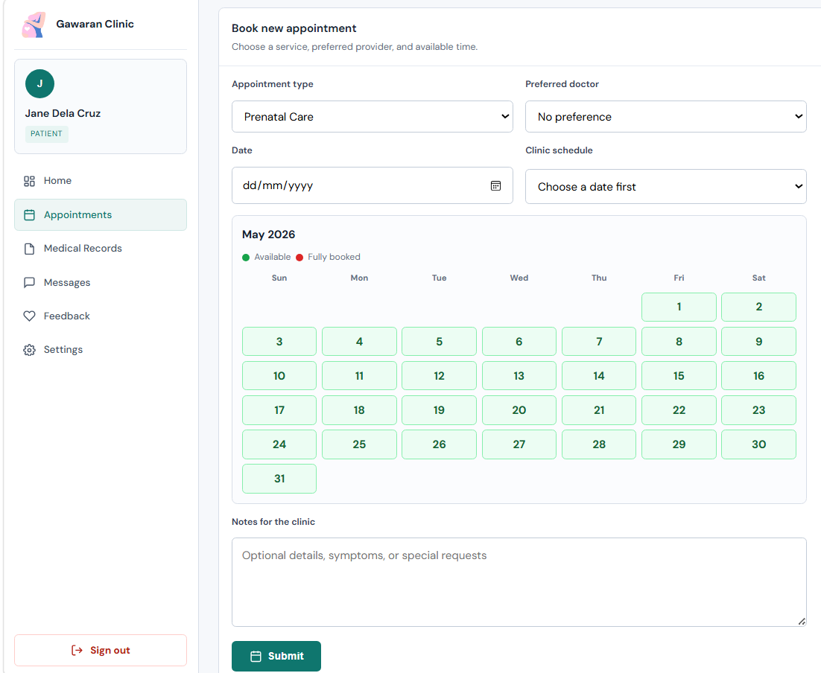

Figure 4.4: Medical Records Page
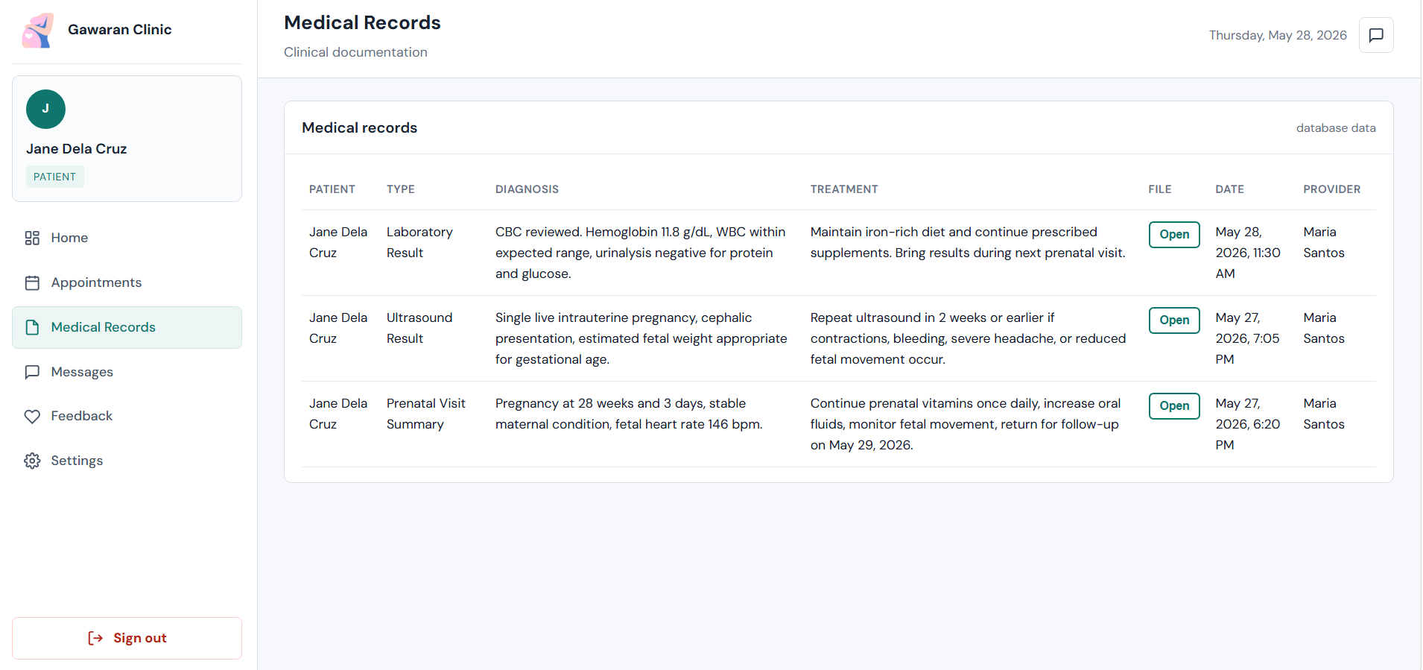

The medical records page shows the patient’s clinical documents and results. It displays the type of record, diagnosis, treatment notes, file access button, date, and provider. This allows patients to conveniently view laboratory results, ultrasound findings, and prenatal visit summaries.

Figure 4.5: Messages Page
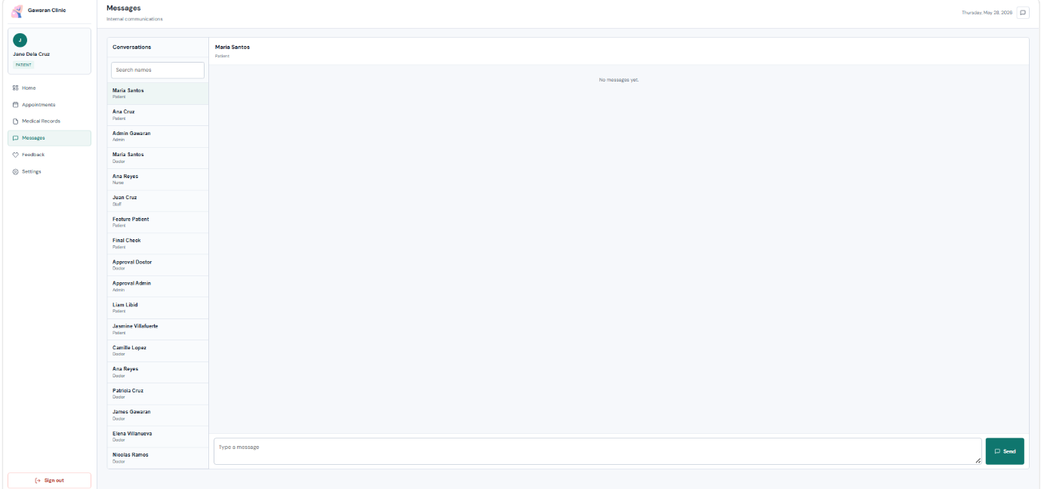

The messages page provides internal communication between the patient and clinic users such as doctors, nurses, staff, and administrators. It includes a contact list, message area, and message input box, allowing users to send and receive clinic-related messages.

Figure 4.6: Feedback Page
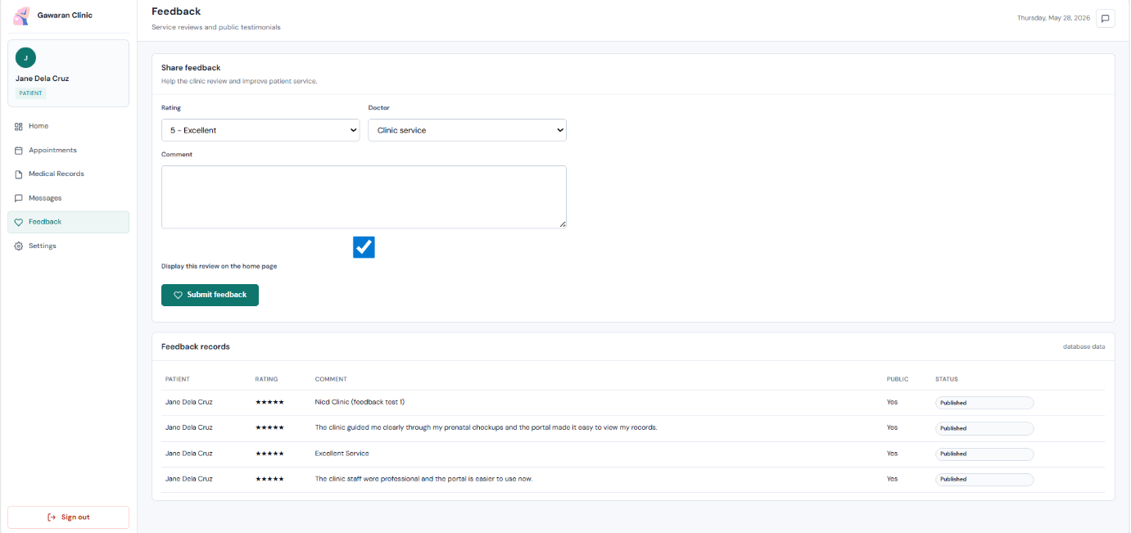

The feedback page allows patients to rate the clinic service, choose whether the feedback is for the clinic or a specific doctor, write comments, and decide if the review may be displayed publicly. The lower section shows previously submitted feedback records and their publication status
.
Figure 4.7: Settings and Login History Page
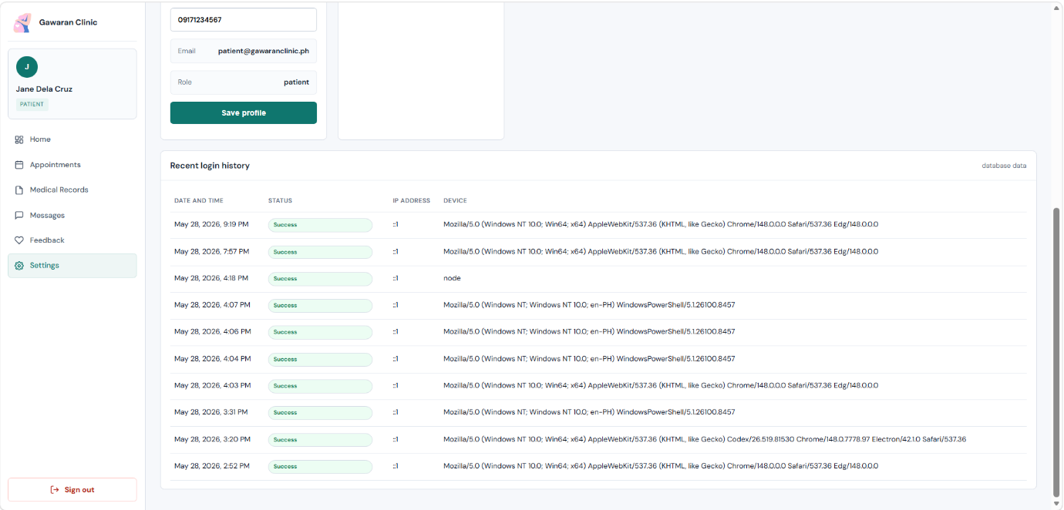

The settings page allows the patient to update profile information and view account details such as email and role. It also displays recent login history, including date and time, login status, IP address, and device information, which helps monitor account activity and security.

Figure 4.8: Grantt Chart
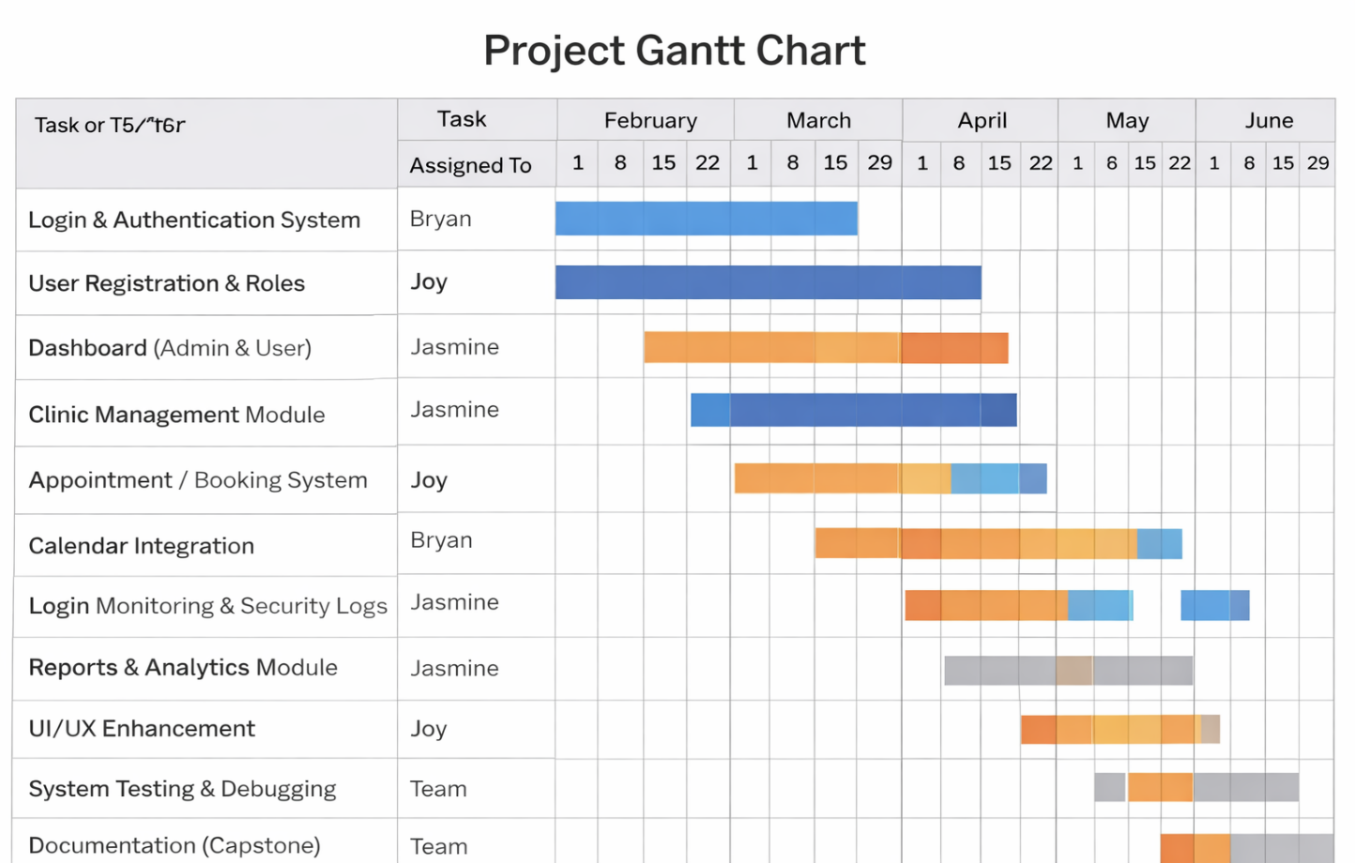

Source Code:
API:
const express = require('express');
const { supabaseAdmin } = require('../lib/supabase');
const { listLocalAppointments } = require('../lib/localAuth');
const { verifyToken } = require('../middleware/auth');

const router = express.Router();

function todayIsoDate() {
return new Date().toISOString().split('T')[0];
}

function emptyStats(role, localAppointments = [], source = 'database') {
if (role === 'admin' || role === 'staff') {
return {
widgets: { patientsAdmitted: 0, deliveriesToday: 0, activeStaff: 0, pendingAppointments: 0 },
charts: { patientStatistics: [], staffPerformance: [] },
source,
};
}

if (role === 'doctor' || role === 'nurse') {
return {
widgets: { patientsToday: 0, scheduledDeliveries: 0, labRequests: 0, notifications: 0 },
dutyRoster: [],
source,
};
}

const upcoming = localAppointments
.filter((appointment) => appointment.date && new Date(appointment.date) >= new Date())
.sort((a, b) => new Date(a.date) - new Date(b.date))[0];

return {
widgets: {
nextAppointment: upcoming?.date || null,
medicalRecords: 0,
labResults: 0,
medications: 0,
},
tasks: upcoming ? [{ title: upcoming.type, date: upcoming.date, type: 'appointment' }] : [],
source,
};
}

router.get('/dashboard/stats', verifyToken, async (req, res) => {
const role = req.user.role;

if (req.user.isLocal || !supabaseAdmin) {
return res.json(emptyStats(role, listLocalAppointments(req.user), req.user.isLocal ? 'local-database' : 'database'));
}

try {
if (role === 'admin' || role === 'staff') {
const [patients, deliveries, staff, appointments, patientStats, staffPerf] = await Promise.all([
supabaseAdmin.from('patients').select('id', { count: 'exact', head: true }).eq('status', 'admitted'),
supabaseAdmin.from('deliveries').select('id', { count: 'exact', head: true }).eq('delivery_date', todayIsoDate()),
supabaseAdmin.from('profiles').select('id', { count: 'exact', head: true }).in('role', ['doctor', 'nurse', 'staff']).eq('is_active', true),
supabaseAdmin.from('appointments').select('id', { count: 'exact', head: true }).eq('status', 'pending'),
supabaseAdmin.from('patient_statistics').select('month, count, year').order('year', { ascending: true }).order('id', { ascending: true }).limit(12),
supabaseAdmin.from('staff_performance').select('name, score, period').order('score', { ascending: false }).limit(5),
]);

return res.json({
widgets: {
patientsAdmitted: patients.count || 0,
deliveriesToday: deliveries.count || 0,
activeStaff: staff.count || 0,
pendingAppointments: appointments.count || 0,
},
charts: {
patientStatistics: patientStats.data || [],
staffPerformance: staffPerf.data || [],
},
source: 'database',
});
}

if (role === 'doctor' || role === 'nurse') {
const [patientsToday, scheduledDeliveries, labRequests, notifications, roster] = await Promise.all([
supabaseAdmin.from('appointments').select('id', { count: 'exact', head: true }).gte('appointment_date', `${todayIsoDate()}T00:00:00`).lt('appointment_date', `${todayIsoDate()}T23:59:59`),
supabaseAdmin.from('deliveries').select('id', { count: 'exact', head: true }).gte('delivery_date', todayIsoDate()),
supabaseAdmin.from('lab_results').select('id', { count: 'exact', head: true }).eq('status', 'pending'),
supabaseAdmin.from('notifications').select('id', { count: 'exact', head: true }).eq('user_id', req.user.id).eq('is_read', false),
supabaseAdmin.from('staff_schedules').select('shift_type, department, profiles(first_name, last_name)').eq('shift_date', todayIsoDate()).limit(10),
]);

return res.json({
widgets: {
patientsToday: patientsToday.count || 0,
scheduledDeliveries: scheduledDeliveries.count || 0,
labRequests: labRequests.count || 0,
notifications: notifications.count || 0,
},
dutyRoster: (roster.data || []).map((item) => ({
name: `${item.profiles?.first_name || ''} ${item.profiles?.last_name || ''}`.trim() || 'Staff',
shift: item.shift_type || 'Scheduled',
department: item.department || 'Clinical',
})),
source: 'database',
});
}

const [nextAppt, records, labs, meds] = await Promise.all([
supabaseAdmin
.from('appointments')
.select('appointment_date, type')
.eq('patient_id', req.user.id)
.gte('appointment_date', new Date().toISOString())
.order('appointment_date', { ascending: true })
.limit(1)
.maybeSingle(),
supabaseAdmin.from('medical_records').select('id', { count: 'exact', head: true }).eq('patient_id', req.user.id),
supabaseAdmin.from('lab_results').select('id', { count: 'exact', head: true }).eq('patient_id', req.user.id),
supabaseAdmin.from('medications').select('id', { count: 'exact', head: true }).eq('patient_id', req.user.id).eq('status', 'active'),
]);

return res.json({
widgets: {
nextAppointment: nextAppt.data?.appointment_date || null,
medicalRecords: records.count || 0,
labResults: labs.count || 0,
medications: meds.count || 0,
},
tasks: nextAppt.data
? [{ title: nextAppt.data.type || 'Appointment', date: nextAppt.data.appointment_date, type: 'appointment' }]
: [],
source: 'database',
});
} catch (err) {
return res.status(500).json({ error: err.message || 'Unable to load dashboard data.' });
}
});

router.get('/modules', verifyToken, (req, res) => {
res.json({
modules: [
{ id: 'patients', name: 'Patient Management', icon: 'users', roles: ['admin', 'doctor', 'nurse', 'staff'] },
{ id: 'records', name: 'Medical Records', icon: 'file-medical', roles: ['admin', 'doctor', 'nurse', 'patient'] },
{ id: 'staff-mgmt', name: 'Doctor & Midwife Management', icon: 'user-md', roles: ['admin'] },
{ id: 'lab', name: 'Laboratory & Diagnostics', icon: 'flask', roles: ['admin', 'doctor', 'nurse', 'patient'] },
{ id: 'admin', name: 'Administration & Security', icon: 'shield', roles: ['admin'] },
{ id: 'comms', name: 'Communication & Notifications', icon: 'bell', roles: ['admin', 'doctor', 'nurse', 'staff', 'patient'] },
{ id: 'reports', name: 'Reporting & Analytics', icon: 'chart-bar', roles: ['admin', 'doctor', 'staff'] },
].filter((m) => m.roles.includes(req.user.role)),
features: {
mobileApp: false,
realTimeMonitoring: false,
multiLanguage: ['en'],
cloudBackup: Boolean(supabaseAdmin),
encryption: 'HTTPS in transit; database storage depends on the configured provider',
},
});
});

module.exports = router;

Audit.js
const express = require('express');
const { supabaseAdmin } = require('../lib/supabase');
const { verifyToken } = require('../middleware/auth');
const { requireRole } = require('../middleware/rbac');

const router = express.Router();

router.get('/', verifyToken, requireRole('admin'), async (req, res) => {
if (!supabaseAdmin) {
return res.status(503).json({ error: 'Database not configured.' });
}

const limit = Math.min(Number(req.query.limit) || 50, 200);
const { data, error } = await supabaseAdmin
.from('audit_logs')
.select('id, user_id, action, details, ip_address, created_at, profiles(first_name, last_name, email)')
.order('created_at', { ascending: false })
.limit(limit);

if (error) {
return res.status(500).json({ error: error.message });
}

res.json({ logs: data });
});

module.exports = router;

Auth.js

const express = require('express');
const { supabaseAdmin } = require('../lib/supabase');
const { sendOtpEmail } = require('../lib/email');
const {
createLocalSession,
createLocalUser,
findLocalUserByEmail,
recordLocalLogin,
verifyLocalPassword,
} = require('../lib/localAuth');
const { getDashboardPath } = require('../middleware/rbac');

const router = express.Router();
const INCORRECT_LOGIN_MESSAGE = 'Incorrect Email or Password';

const NAME_RE = /^[A-Za-z\s'-]{2,60}$/;
const PHONE_RE = /^09\d{9}$/;
const EMAIL_RE = /^[^\s@]+@[^\s@]+\.[^\s@]{2,}$/;

function cleanText(value) {
return typeof value === 'string' ? value.trim().replace(/\s+/g, ' ') : '';
}

function normalizeEmail(value) {
return cleanText(value).toLowerCase();
}

function validatePassword(value) {
if (typeof value !== 'string' || value.length < 8 || value.length > 72) {
return 'Password must be 8 to 72 characters.';
}
if (!/[A-Z]/.test(value) || !/[0-9]/.test(value) || !/[^A-Za-z0-9]/.test(value)) {
return 'Password must include at least one uppercase letter, one number, and one special character.';
}
return null;
}

function validateRegistration(body) {
const firstName = cleanText(body.firstName);
const middleName = cleanText(body.middleName);
const lastName = cleanText(body.lastName);
const phone = cleanText(body.phone);
const email = normalizeEmail(body.email);
const password = typeof body.password === 'string' ? body.password : '';
const errors = {};

if (!NAME_RE.test(firstName)) errors.firstName = 'First name must be 2 to 60 letters.';
if (middleName && !NAME_RE.test(middleName)) errors.middleName = 'Middle name must contain letters only.';
if (!NAME_RE.test(lastName)) errors.lastName = 'Last name must be 2 to 60 letters.';
if (!PHONE_RE.test(phone)) errors.phone = 'Phone number must be exactly 11 digits and start with 09.';
if (!EMAIL_RE.test(email) || email.length > 254) errors.email = 'Enter a valid email address.';

const passwordError = validatePassword(password);
if (passwordError) errors.password = passwordError;
if (!body.acceptTerms) errors.acceptTerms = 'You must accept the Terms of Service.';

return {
values: { firstName, middleName, lastName, phone, email, password },
errors,
};
}

function validationResponse(res, errors) {
const firstError = Object.values(errors)[0] || 'Please check the form and try again.';
return res.status(400).json({ error: firstError, errors });
}

async function logAudit(userId, action, details = {}, ip = null) {
if (!supabaseAdmin) return;
await supabaseAdmin.from('audit_logs').insert({
user_id: userId,
action,
details,
ip_address: ip,
});
}

async function checkLockout(email) {
const { data } = await supabaseAdmin
.from('login_attempts')
.select('attempt_count, locked_until')
.eq('email', email.toLowerCase())
.maybeSingle();

if (data?.locked_until && new Date(data.locked_until) > new Date()) {
const mins = Math.ceil((new Date(data.locked_until) - new Date()) / 60000);
return { locked: true, minutes: mins };
}
return { locked: false, attempts: data?.attempt_count || 0 };
}

async function recordFailedLogin(email, ip) {
const { data } = await supabaseAdmin
.from('login_attempts')
.select('attempt_count')
.eq('email', email.toLowerCase())
.maybeSingle();

const count = (data?.attempt_count || 0) + 1;
const lockedUntil =
count >= MAX_ATTEMPTS
? new Date(Date.now() + LOCKOUT_MINUTES * 60 * 1000).toISOString()
: null;

await supabaseAdmin.from('login_attempts').upsert(
{
email: email.toLowerCase(),
attempt_count: count,
locked_until: lockedUntil,
last_attempt_at: new Date().toISOString(),
},
{ onConflict: 'email' }
);

if (lockedUntil) {
await supabaseAdmin
.from('profiles')
.update({ is_locked: true })
.eq('email', email.toLowerCase());
}

return { count, locked: !!lockedUntil };
}

async function recordLoginHistory({ userId = null, email, success, req }) {
const device = req.get('user-agent') || null;
if (!supabaseAdmin) return;
const { error } = await supabaseAdmin.from('login_history').insert({
user_id: userId,
email: email?.toLowerCase(),
success,
ip_address: req.ip,
device,
});
if (error) console.warn(`Login history not recorded: ${error.message}`);
}

async function clearLoginAttempts(email) {
await supabaseAdmin.from('login_attempts').delete().eq('email', email.toLowerCase());
await supabaseAdmin.from('profiles').update({ is_locked: false }).eq('email', email.toLowerCase());
}

function getAppUrl() {
return process.env.APP_URL || `http://localhost:${process.env.PORT || 3000}`;
}

async function createAndSendOtp(userId, email, firstName) {
const otp = String(Math.floor(100000 + Math.random() * 900000));
const expires = new Date(Date.now() + 10 * 60 * 1000).toISOString();

await supabaseAdmin.from('otp_codes').upsert(
{ user_id: userId, code: otp, expires_at: expires },
{ onConflict: 'user_id' }
);

let emailResult = { sent: false };
try {
emailResult = await sendOtpEmail({ to: email, code: otp, firstName });
} catch (err) {
if (process.env.NODE_ENV !== 'development') {
throw err;
}
emailResult = { sent: false, devMode: true, error: err.message };
}

return { otp, emailResult };
}

router.post('/register', async (req, res) => {
const { values, errors } = validateRegistration(req.body || {});
if (Object.keys(errors).length) {
return validationResponse(res, errors);
}

try {
const existingLocal = findLocalUserByEmail(values.email);
if (existingLocal) {
return res.status(409).json({ error: 'An account already exists with this email address.' });
}

if (supabaseAdmin) {
const { data: existingProfile } = await supabaseAdmin
.from('profiles')
.select('id')
.eq('email', values.email)
.maybeSingle();

if (existingProfile) {
return res.status(409).json({ error: 'An account already exists with this email address.' });
}

const { data: authData, error: signUpError } = await supabaseAdmin.auth.admin.createUser({
email: values.email,
password: values.password,
email_confirm: true,
user_metadata: {
first_name: values.firstName,
middle_name: values.middleName,
last_name: values.lastName,
phone: values.phone,
},
});

if (!signUpError) {
const userId = authData.user.id;
const { error: profileError } = await supabaseAdmin.from('profiles').upsert(
{
id: userId,
email: values.email,
first_name: values.firstName,
middle_name: values.middleName || null,
last_name: values.lastName,
phone: values.phone,
role: 'patient',
is_locked: false,
},
{ onConflict: 'id' }
);

if (profileError) {
await supabaseAdmin.auth.admin.deleteUser(userId);
return res.status(400).json({ error: profileError.message });
}

await logAudit(userId, 'account_created', { email: values.email }, req.ip);
return res.status(201).json({ message: 'Account created successfully.', redirect: '/login.html' });
}

const duplicate = /already|registered|exists/i.test(signUpError.message);
if (duplicate) {
return res.status(409).json({ error: signUpError.message });
}

console.warn(`Supabase signup failed, using local account fallback: ${signUpError.message}`);
}

createLocalUser(values);
return res.status(201).json({ message: 'Account created successfully.', redirect: '/login.html' });
} catch (err) {
if (err.code === 'duplicate') {
return res.status(409).json({ error: err.message });
}
console.error('Registration error:', err);
return res.status(500).json({ error: 'Account creation failed. Please try again.' });
}
});

router.post('/login', async (req, res) => {
const { email, password, rememberDevice } = req.body;
const cleanEmail = normalizeEmail(email);

if (!EMAIL_RE.test(cleanEmail) || !password) {
return res.status(400).json({ error: INCORRECT_LOGIN_MESSAGE });
}

let localUser = null;
try {
localUser = verifyLocalPassword(cleanEmail, password);
} catch (err) {
if (err.code === 'temporary_password_expired') {
return res.status(423).json({ error: err.message });
}
throw err;
}

if (!supabaseAdmin) {
if (!localUser) {
recordLocalLogin({ email: cleanEmail, success: false, ip: req.ip, device: req.get('user-agent') });
return res.status(401).json({ error: INCORRECT_LOGIN_MESSAGE });
}
recordLocalLogin({ user: localUser, email: cleanEmail, success: true, ip: req.ip, device: req.get('user-agent') });
const session = createLocalSession(localUser);
return res.json({ session, role: localUser.role, redirect: getDashboardPath(localUser.role) });
}

const { data, error } = await supabaseAdmin.auth.signInWithPassword({ email: cleanEmail, password });

if (error) {
if (localUser) {
await clearLoginAttempts(cleanEmail);
recordLocalLogin({ user: localUser, email: cleanEmail, success: true, ip: req.ip, device: req.get('user-agent') });
const session = createLocalSession(localUser);
return res.json({ session, role: localUser.role, redirect: getDashboardPath(localUser.role) });
}

await recordLoginHistory({ email: cleanEmail, success: false, req });
await logAudit(null, 'login_failed', { email: cleanEmail }, req.ip);
return res.status(401).json({ error: INCORRECT_LOGIN_MESSAGE });
}

await clearLoginAttempts(cleanEmail);

const { data: profile } = await supabaseAdmin
.from('profiles')
.select('role, two_factor_enabled, temporary_password_expires_at')
.eq('id', data.user.id)
.single();

if (profile?.temporary_password_expires_at && new Date(profile.temporary_password_expires_at) < new Date()) {
return res.status(423).json({ error: 'Temporary password expired. Please contact the clinic administrator.' });
}

await logAudit(data.user.id, 'login_success', { rememberDevice: !!rememberDevice }, req.ip);
await recordLoginHistory({ userId: data.user.id, email: cleanEmail, success: true, req });

if (profile?.two_factor_enabled) {
const { data: userProfile } = await supabaseAdmin
.from('profiles')
.select('first_name, email')
.eq('id', data.user.id)
.single();

const { otp, emailResult } = await createAndSendOtp(
data.user.id,
userProfile?.email || email,
userProfile?.first_name
);

await logAudit(data.user.id, 'otp_sent', { emailSent: emailResult.sent }, req.ip);

return res.json({
requiresOtp: true,
userId: data.user.id,
session: data.session,
emailSent: emailResult.sent,
message: emailResult.sent
? 'A verification code was sent to your email.'
: 'Enter the verification code (check server console in development).',
devOtp:
process.env.NODE_ENV === 'development' && !emailResult.sent ? otp : undefined,
});
}

res.json({
session: data.session,
role: profile?.role || 'patient',
redirect: getDashboardPath(profile?.role || 'patient'),
});
});

router.post('/verify-otp', async (req, res) => {
if (!supabaseAdmin) {
return res.status(503).json({ error: 'Database not configured.' });
}

const { userId, code, session } = req.body;

const { data: otpRow } = await supabaseAdmin
.from('otp_codes')
.select('code, expires_at')
.eq('user_id', userId)
.single();

if (!otpRow || otpRow.code !== code || new Date(otpRow.expires_at) < new Date()) {
return res.status(401).json({ error: 'Invalid or expired verification code.' });
}

await supabaseAdmin.from('otp_codes').delete().eq('user_id', userId);

const { data: profile } = await supabaseAdmin
.from('profiles')
.select('role')
.eq('id', userId)
.single();

await logAudit(userId, 'otp_verified', {}, req.ip);

res.json({
session,
role: profile?.role || 'patient',
redirect: getDashboardPath(profile?.role || 'patient'),
});
});

router.post('/resend-otp', async (req, res) => {
if (!supabaseAdmin) {
return res.status(503).json({ error: 'Database not configured.' });
}

const { userId } = req.body;
if (!userId) {
return res.status(400).json({ error: 'User ID is required.' });
}

const { data: profile } = await supabaseAdmin
.from('profiles')
.select('email, first_name, two_factor_enabled')
.eq('id', userId)
.single();

if (!profile?.two_factor_enabled) {
return res.status(400).json({ error: 'Two-factor authentication is not enabled for this account.' });
}

try {
const { otp, emailResult } = await createAndSendOtp(userId, profile.email, profile.first_name);
await logAudit(userId, 'otp_resent', { emailSent: emailResult.sent }, req.ip);

res.json({
message: emailResult.sent ? 'A new code was sent to your email.' : 'New code generated.',
emailSent: emailResult.sent,
devOtp: process.env.NODE_ENV === 'development' && !emailResult.sent ? otp : undefined,
});
} catch (err) {
res.status(500).json({ error: err.message || 'Failed to send verification email.' });
}
});

router.post('/password-updated', async (req, res) => {
res.json({ message: 'Password updated successfully.' });
});

router.post('/forgot-password', async (req, res) => {
if (!supabaseAdmin) {
return res.status(503).json({ error: 'Database not configured.' });
}

const { email } = req.body;
if (!email?.trim()) {
return res.status(400).json({ error: 'Email is required.' });
}

const redirectTo = `${getAppUrl()}/reset-password.html`;

const { error } = await supabaseAdmin.auth.resetPasswordForEmail(email.trim(), {
redirectTo,
});

if (error) {
console.error('Password reset error:', error.message);
}

await logAudit(null, 'password_reset_requested', { email: email.toLowerCase() }, req.ip);

res.json({
message:
'If an account exists with that email, you will receive a password reset link shortly. Check your inbox and spam folder.',
redirectTo,
});
});

module.exports = router;

GITHUB REPOSITORY:
hestia13-jas/MaternalClinic

APPENDIX E — Evaluation Forms
System Evaluation Form
Project Title: Gawaran Maternal Clinic Management System
Evaluator Name: _______________________________
Role: ☐ Patient ☐ Doctor ☐ Admin ☐ Other: ___________
Date Evaluated: _______________________________
Rating Scale:

Rating | Description
5 | Excellent
4 | Very Good
3 | Good
2 | Fair
1 | Poor

Criteria | 5 | 4 | 3 | 2 | 1
The system is easy to use and understand. | ☐ | ☐ | ☐ | ☐ | ☐
The login and account process works properly. | ☐ | ☐ | ☐ | ☐ | ☐
The dashboard clearly shows important information. | ☐ | ☐ | ☐ | ☐ | ☐
The appointment/queue process is organized and useful. | ☐ | ☐ | ☐ | ☐ | ☐
The medical records feature is helpful and accessible. | ☐ | ☐ | ☐ | ☐ | ☐
The reports section provides useful clinic information. | ☐ | ☐ | ☐ | ☐ | ☐
The system design is clean and professional. | ☐ | ☐ | ☐ | ☐ | ☐
The system responds properly to user actions. | ☐ | ☐ | ☐ | ☐ | ☐
The system helps improve clinic workflow. | ☐ | ☐ | ☐ | ☐ | ☐
Overall satisfaction with the system. | ☐ | ☐ | ☐ | ☐ | ☐

Comments / Suggestions:

Evaluator Signature: _______________________________

Evaluation Forms
System Evaluation Form
Project Title: Gawaran Maternal Clinic Management System
Total Respondents: 83
Rating Scale: 5 - Excellent, 4 - Very Good, 3 - Good, 2 - Fair, 1 - Poor
Criteria | 5 | 4 | 3 | 2 | 1
The system is easy to use and understand. | 52 | 24 | 7 | 0 | 0
The login and account process works properly. | 49 | 26 | 8 | 0 | 0
The dashboard clearly shows important information. | 50 | 25 | 8 | 0 | 0
The appointment/queue process is organized and useful. | 47 | 27 | 8 | 1 | 0
The medical records feature is helpful and accessible. | 48 | 25 | 9 | 1 | 0
The reports section provides useful clinic information. | 45 | 28 | 9 | 1 | 0
The system design is clean and professional. | 51 | 24 | 8 | 0 | 0
The system responds properly to user actions. | 46 | 29 | 7 | 1 | 0
The system helps improve clinic workflow. | 50 | 25 | 7 | 1 | 0
Overall satisfaction with the system. | 53 | 23 | 7 | 0 | 0
Evaluation Result Summary
Based on the evaluation results, most respondents rated the system as Excellent or Very Good. This indicates that the Gawaran Maternal Clinic Management System was generally accepted by the evaluators in terms of usability, functionality, design, responsiveness, and usefulness in improving clinic workflow.

Pie Chart Results
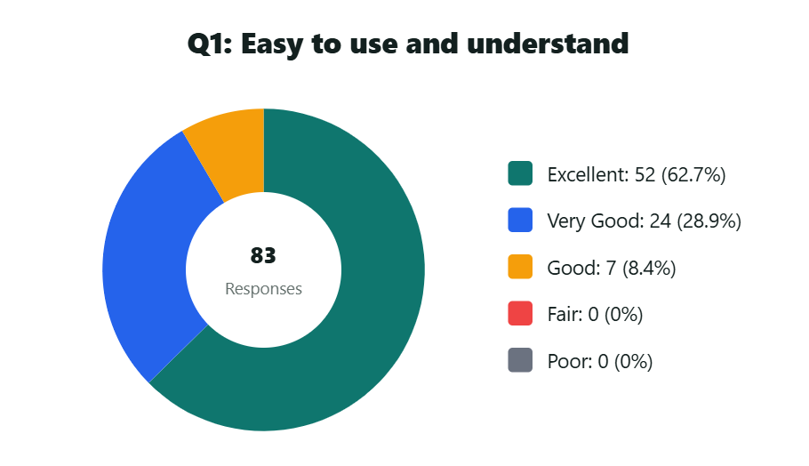
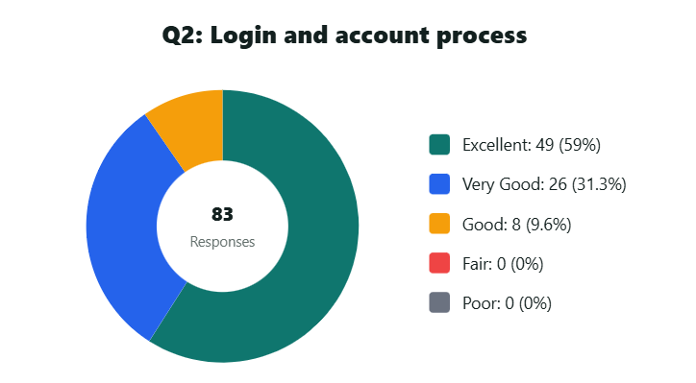
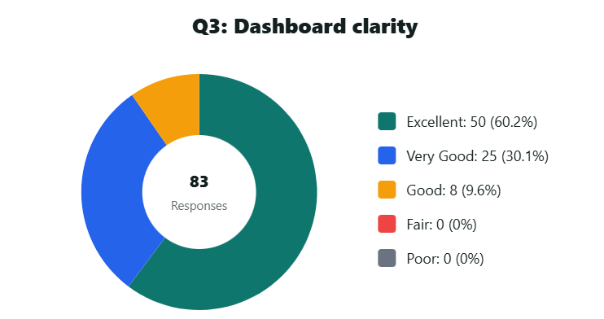
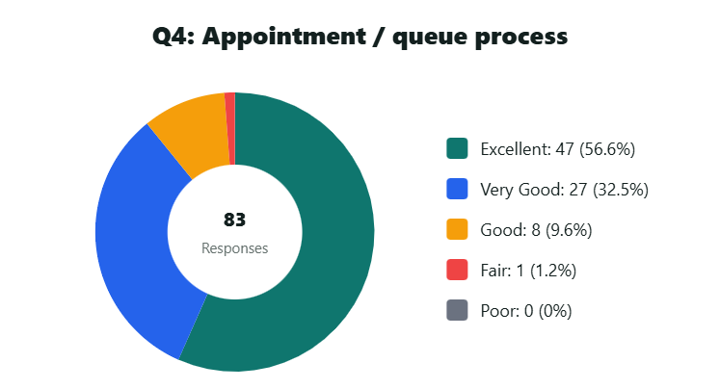
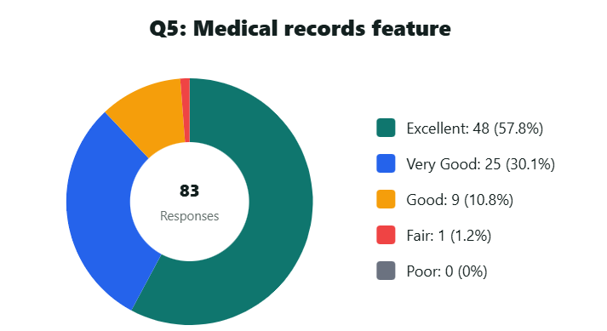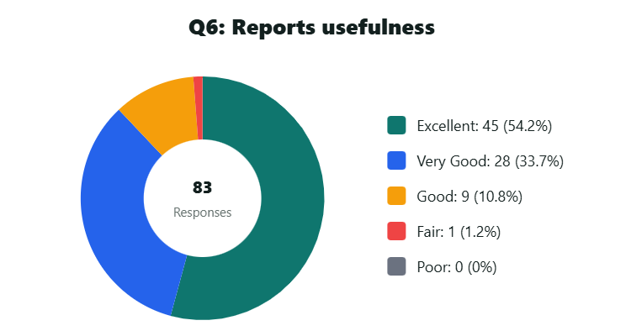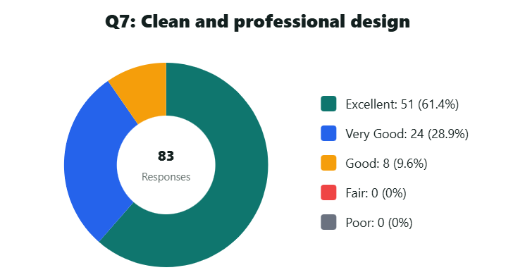
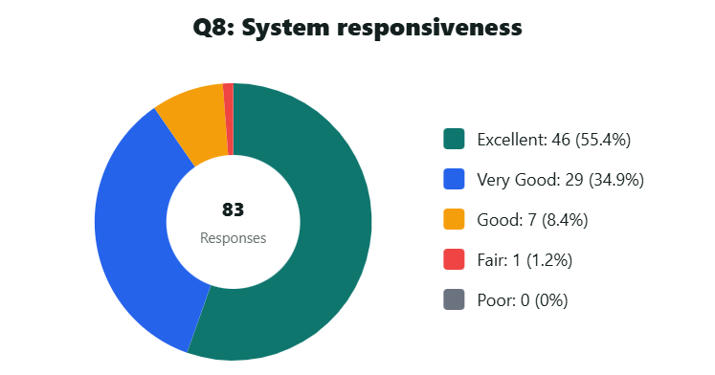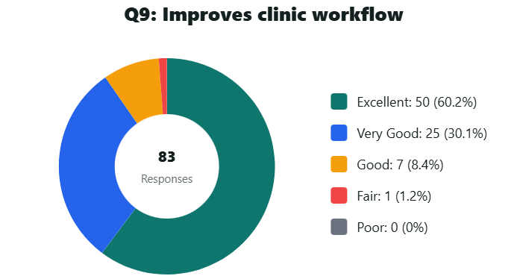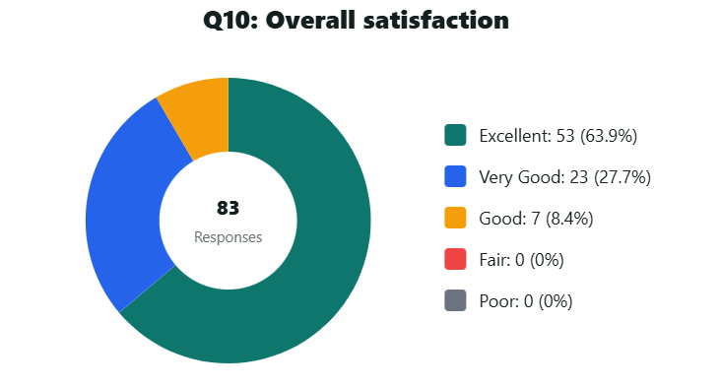
List of Evaluators / Respondents
No. | Name
1 | Donnabelle Sy Bumanlag
2 | Jonathan Conde Calido
3 | Jimmy Peurte Cameno
4 | Joanna Cid Capisanan
5 | Irish Gaspi Casalla
6 | Esperanza Castro Castano
7 | Roberto Alvaro Cimanes
8 | Mary Jay Condez Condrada
9 | Reggie Laurente Cuyson
10 | Denissa May Costales Dalina
11 | Erlinda Delos Santos De Guzman
12 | Priscilla Sapalasan Dela Cruz
13 | Josie Marcelino Depra
14 | Mauro Mentes Derecho
15 | Jenelyn Torres Domingo
16 | Madel Torres Domingo
17 | Lilibeth Javier Dusaban
18 | Edrian Ebol Edillor
19 | Milke Glico Edillor
20 | Melissa Abanador Ellema
21 | Crisellamarie Paz Ereno
22 | Sonia Magno Ernacio
23 | Reynaldo Danganan Espino
24 | Sweet Lalaine Suayan Espiritu
25 | Norberto Caro Francisco
26 | Mary Rose Perino Fundario
27 | Nizha Mae Calitis Garcia
28 | John Esmael Mendoza Gepiga
29 | Esther Curit Gontinias
30 | Dino Macabago Gubat
31 | Edison Llagas Guevarra
32 | Jhon Emmanuel Gadiana Gura
33 | Randy Estupin Hernandez
34 | Krystal Joy Luna Intano
35 | Ma Cristina Torrefranca Intano
36 | Mylene Labog Jovita
37 | Junie Yparraguirre Lampunay
38 | Armand Tiongson Lorenzo
39 | Ritabelle Lamanilao Lumbocan
40 | Jannah Villapando Macapansir
41 | Donald Buenafe Magallanes
42 | Rachel Bayale Magdaong
43 | Lei Edzekiel Macalintal Magracia
44 | Romeo Rodabia Maluto
45 | Michelle Mamangon
46 | Junifer Tecon Maravillas
47 | John Michael Edillor Maravillas
48 | Jenny Lyn Delos Reyes Mariano
49 | Alvin Napiza Martinez
50 | Lailanie Aruta Mendoza
51 | Colino Badeo Mendoza
52 | Oswald Brion Mendoza
53 | Elenita Medina Molina
54 | Arnel Catam-isan Morada
55 | Ericson Ausan Moratin
56 | Lovely Ann Antaran Morillo
57 | Jovie Lareza Nolsol
58 | Jericho Norona Obguia
59 | Roberto Estupin Ocampo
60 | Danica Jarmin Oliveros
61 | Ronald Mendoza Orpiada
62 | Elena Englis Paglinawan
63 | Virgie Net Chavez Patena
64 | Jerald Consigna Patricio
65 | Isidor Montenegro Patricio
66 | Rene Suansing Poblacion
67 | Robert Guillermo Porillo
68 | Reynald Molomolo Puntorio
69 | Jerry Obanel Quinagutan
70 | Jocelyn Tayabas Quinalayo
71 | Bernardina Tayabas Quinalayo
72 | Julieta Melendres Ramos
73 | Jean Dusaban Reyes
74 | Marlon Calido Sabater
75 | Ana Marie Bacas Salvadico
76 | Jericho Jay Villafuerte Santos
77 | Jacinto Marco Santos
78 | Michelle Calido Selga
79 | William Renz Pelenio Sikat
80 | Roberto Gonzaga Sumalo
81 | Regina Gono Tacloban
82 | Jovito Odias Tendenilla
83 | Ranilo Vizcarra Tolentino

References
Alhassan, R. K., Nketiah-Amponsah, E., & Arhinful, D. K. (2021). Digital Appointment Systems and Patient Satisfaction in Healthcare. Journal of Health Informatics.
Menachemi, N., & Collum, T. H. (2011). Benefits and Drawbacks of Electronic Health Record Systems. Risk Management and Healthcare Policy.
McGowan, J. (2012). Laboratory Information Systems and Their Role in Healthcare Efficiency. Clinical Laboratory Science Review.
Ventola, C. L. (2014). Mobile Devices and Apps for Health Care Professionals: Uses and Benefits. Pharmacy and Therapeutics Journal.
Rindfleisch, T. C. (1997). Privacy, Information Technology, and Health Care. Communications of the ACM.
Puri, D., & Upadhyay, A. (2021). A Study on Online Appointment Scheduling and Management: A Systematic Review. Bareilly International University.
Maluyo, A. C. III, Osorio, J. C. M. E., Caballero, A. R., & Albina, E. M. (2022). A Web Ecosystem for User-Driven Healthcare Appointment Management. Lyceum of the Philippines University Manila.
Assimilation of Medical Appointment Scheduling Systems and Their Impact. (2023).
Puri, D., & Upadhyay, A. (2021). Integration of Appointment Systems with Electronic Health Records. Journal of Health Informatics.
Maluyo, A. C. III, Osorio, J. C. M. E., Caballero, A. R., & Albina, E. M. (2022). Patient-Centered Digital Appointment Systems. Lyceum of the Philippines University Manila.

